**Experiment No:** 10

**Experiment Name:** Introduction to JavaScript.

**Theory:** JavaScript is a popular programming language that makes web pages interactive and dynamic. It can control HTML elements, respond to user events like clicks, and update content without reloading the page. JavaScript is essential for tasks like form validation, creating animations, and building complex web applications. It runs directly in the browser, making it an important tool for modern web development.

**Variables:** Variables are used to store and manipulate data. JavaScript follows camelCase naming convention for variables.

**Console:** The console is used to see the output in the code terminal.

**Data Types:** JavaScript has several data types, including String, Number, Boolean, Array, Object, and more.

**Math Operators:** Perform basic math operations using operators (+, -, *, /).

**Math Methods:** JavaScript build-in math methods:

**Array:** In Javascript, an array is an object that can store multiple values at once within a single variable.

**String:** Strings represent text. String can be manipulated in various ways.

**Template String:** Template strings, also known as template literals, are a feature in JavaScript that makes working with strings more convenient and readable. Instead of using single or double quotes, template strings use backticks (``).

**Lab Task - 1:** Write a program that declares two variables, ‘*num1’* and ‘*num2’* with numeric values of your choice. The program should calculate and display the sum, difference, product, and quotient of these two numbers.

**Source Code:**

**var num1 = 10;**

**var num2 = 5;**

**var sum = num1 + num2;**

**var difference = num1 - num2;**

**var product = num1 * num2;**

**var quotient = num1 / num2;**

**alert("Sum: " + sum);**

**alert("Difference: " + difference);**

**alert("Product: " + product);**

**alert("Quotient: " + quotient);**

**Output:**

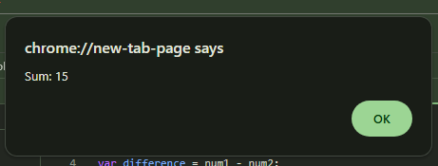

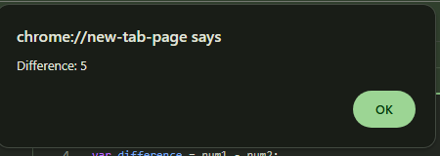

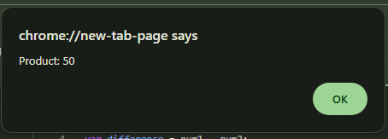

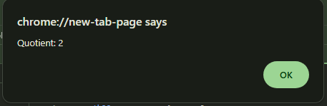

**Lab Task - 2:** Write a JavaScript program that takes a sentence from the user. Then, display:

1. The length of the sentence.

**b)** The position of the first occurrence of a specific word (e.g., 'the') in the sentence using indexOf.

**c)** The sentence is in lowercase format.

**Source Code:**

**var sentence = prompt("Please enter a sentence:");**

**var lengthOfSentence = sentence.length;**

**var positionOfThe = sentence.indexOf('the');**

**var lowerCaseSentence = sentence.toLowerCase();**

**alert("Length of the sentence: " + lengthOfSentence);**

**alert("Position of the first occurrence of 'the': " + positionOfThe);**

**alert("Sentence in lowercase: " + lowerCaseSentence);**

**Output:**

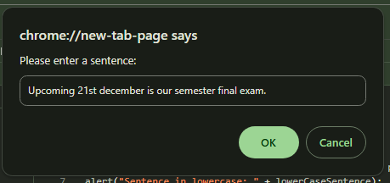

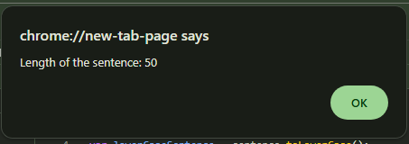

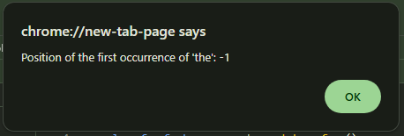

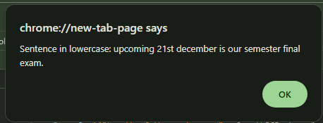

**Lab Task - 3:** Write a JavaScript program that takes your current age as input and calculates the time left until you reach 90 years old in the following format → You have X days, Y weeks, and Z months left. (where X, Y, and Z are replaced with the actual calculated number).

**Source Code:**

**var age = prompt("Please enter your current age:");**

**var yearsLeft = 90 - age;**

**var daysLeft = yearsLeft * 365;**

**var weeksLeft = yearsLeft * 52;**

**var monthsLeft = yearsLeft * 12;**

**alert("You have " + daysLeft + " days, " + weeksLeft + " weeks, and " + monthsLeft + " months left.");**

**Output:**

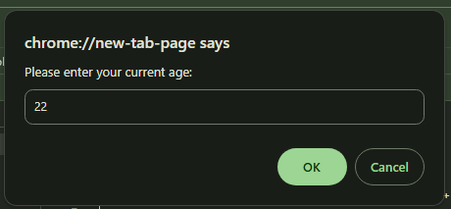

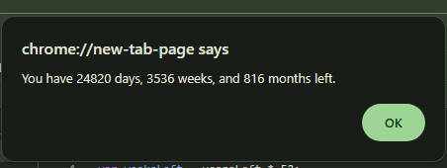

**Discussion:** In today’s lab, we got introduced to JavaScript.JavaScript is a popular programming language that makes web pages interactive and dynamic. It can control HTML elements, respond to user events like clicks, and update content without reloading the page. JavaScript is essential for tasks like form validation, creating animations, and building complex web applications.It runs directly in the browser, making it an important tool for modern web development.By using variable and console tag we completed our lab tasks succesfully.